# Media Analysis - ChatGPT outperforms copywriters in STEP Conference's outdoor adverts

## Short Summary

": "The article highlights how the STEP Conference utilizes ChatGPT as an AI assistant for streamlining outdoor advertising production and content creation, suggesting an emerging role for artificial intelligence in augmenting human productivity within teams."  
}

## Summary

1. **ChatGPT used for STEP Conference's outdoor adverts**: The AI tool has been employed by Dubai-based tech festival STEP Conference to create taglines and content for their outdoor campaigns, surpassing the agency Mink and internal team in performance.  
  
2. **Increased efficiency with AI assistance**: ChatGPT is perceived as an artificial intelligence assistant that enhances productivity within STEP's creative team by automating tasks like copywriting and summarizing content.  
  
3. **Planned continuation of using ChatGPT**: The company plans to maintain the use of ChatGPT, possibly investing in a paid account for broader application across their team, leveraging its capabilities for creating, summarizing, and explaining content.  
  
4. **AI's role in job creation**: Contrary to fears, AI tools like ChatGPT contribute positively to employment by generating jobs that haven't been invented yet, according to one report. This perspective challenges the common narrative of AI replacing human jobs entirely.  
  
5. **AI as a complement not a competitor**: STEP's founder Ray Dargham views ChatGPT and other AI tools as more complimentary than competitive with human talent, emphasizing that AI can assist in performing tasks easier rather than replace them entirely.  
  
6. **Human creativity remains valuable**: Despite the advancements of AI tools like ChatGPT, Dargham asserts that human creativity will always hold immense value and will find ways to utilize its skills more efficiently.  
  
7. **Implications for jobs in creative industries**: The increased use of AI and chatbots across various sectors could lead to the automation of certain tasks traditionally performed by copywriters, potentially impacting job markets in those areas. However, human talent will likely shift towards roles requiring more complex problem-solving and creativity.

## Question 1:

How do the media in this article frame the public discussion about ChatGPT? Are there certain **metaphors** that keep cropping up?

The media frames the public discussion about ChatGPT using metaphors that highlight its transformative potential alongside concerns over job displacement. These include 'outperforming copywriters,' 'creating more jobs than it erases,' acknowledging both AI's role in augmenting human capabilities and its capacity to displace certain jobs.

## Question 2:

Which role does or might the Arabic World play in the development of Artificial Intelligence? Answer with 'Not mentioned' if not applicable.

Not mentioned

## Question 3:

Which use cases of Artificial Intelligence are helpful for the Arabic world based on this article?

The article highlights content creation and summarization for ads, efficient work process by using AI as an assistant, and job complementation/augmentation where human creativity will still be valuable despite potential replacement by AI tools like ChatGPT.

## Question 4:

What is the final message of the article that the author wants to convey? Keep your answer short and precise!

The final message is that AI, including ChatGPT, can both enhance and augment human creativity in industries like advertising, while also potentially replacing some job roles, but ultimately serving as a complementary tool rather than fully replacing human talent.

## Sentiment

The sentiment is <4>

The sentiment of the article is primarily positive towards AI, particularly ChatGPT, while acknowledging potential concerns and limitations.

## Entities

Dargham

## Topic Clusters

### Cluster: 1. AI Ethics and Regulation

ChatGPT, AI ethical considerations, regulatory frameworks for AI

### Cluster: 2. Employment Impact of AI

job displacement due to automation, the need for AI-literate workforce, AI's role in creating new job opportunities

### Cluster: 3. Privacy and Surveillance Concerns

AI-driven data collection and analysis, privacy violations by AI systems, public debate on surveillance technologies

### Cluster: 4. Bias and Fairness in AI

AI models perpetuating or exacerbating societal biases, addressing bias in training datasets, ensuring fairness across different demographics

## Word Clouds

### Wordcloud of content

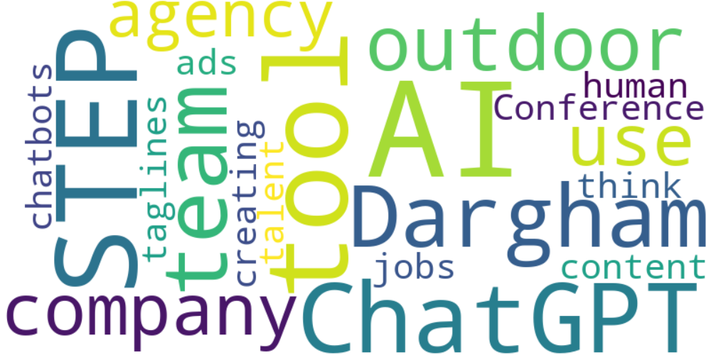

Top 10 words:

- AI: 10  
- STEP: 7  
- ChatGPT: 6  
- like: 6  
- team: 5  
- Dargham: 5  
- outdoor: 4  
- company: 4  
- use: 4  
- agency: 4

### Wordcloud of summary

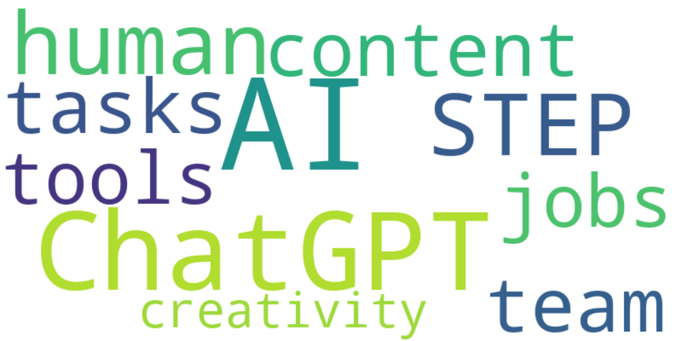

Top 10 words:

- AI: 10  
- ChatGPT: 7  
- STEP: 4  
- human: 4  
- content: 3  
- team: 3  
- tasks: 3  
- like: 3  
- tools: 3  
- jobs: 3